**Lab Practical #05:**

Study the application layer protocol DNS, DHCP, FTP.

**Practical Assignment #05:**

1. **Implement the application layer protocol DNS, DHCP, and FTP. Also check connectivity between them using ping command or PDU utility.**
2. **DNS:**

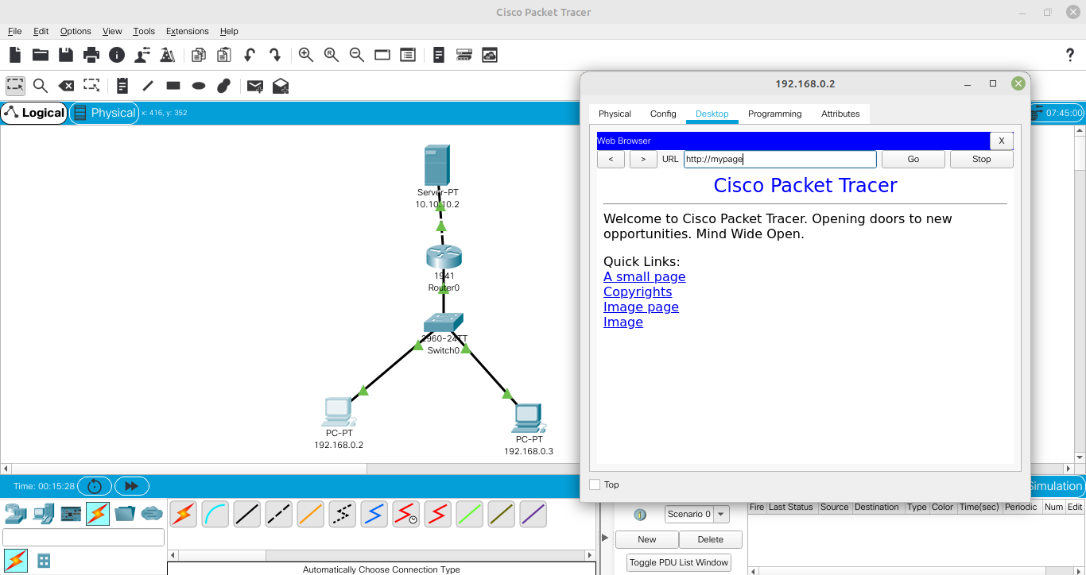

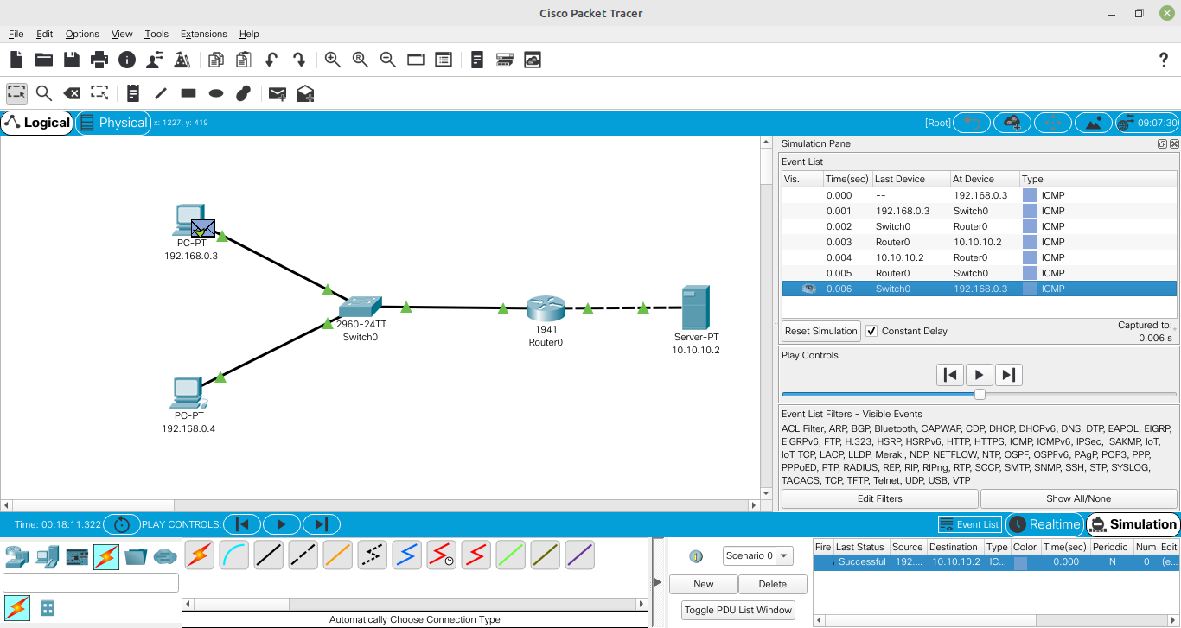

1. **DHCP:**
   1. **Bus**

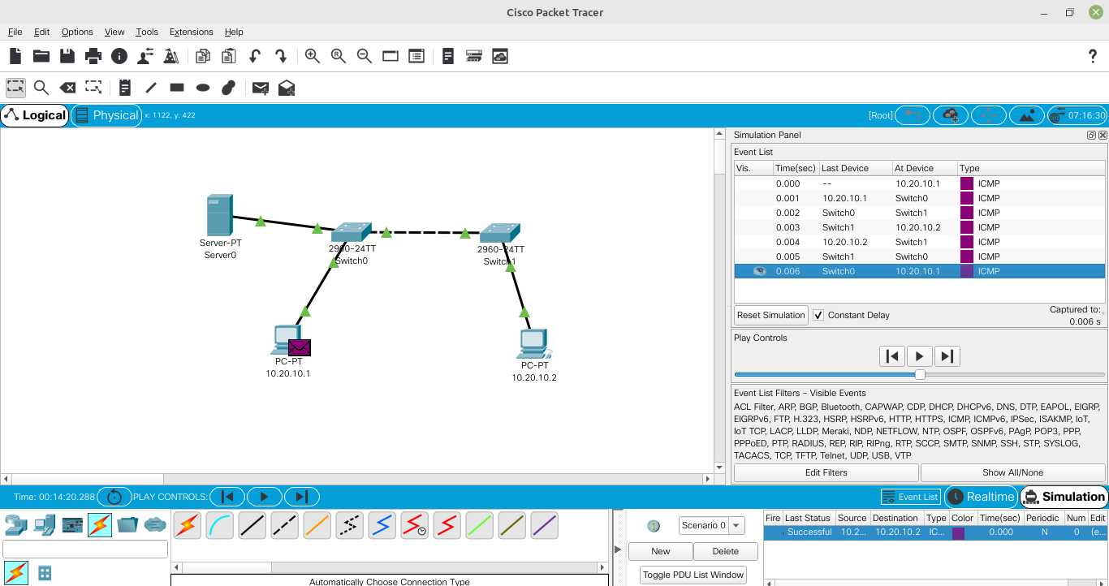

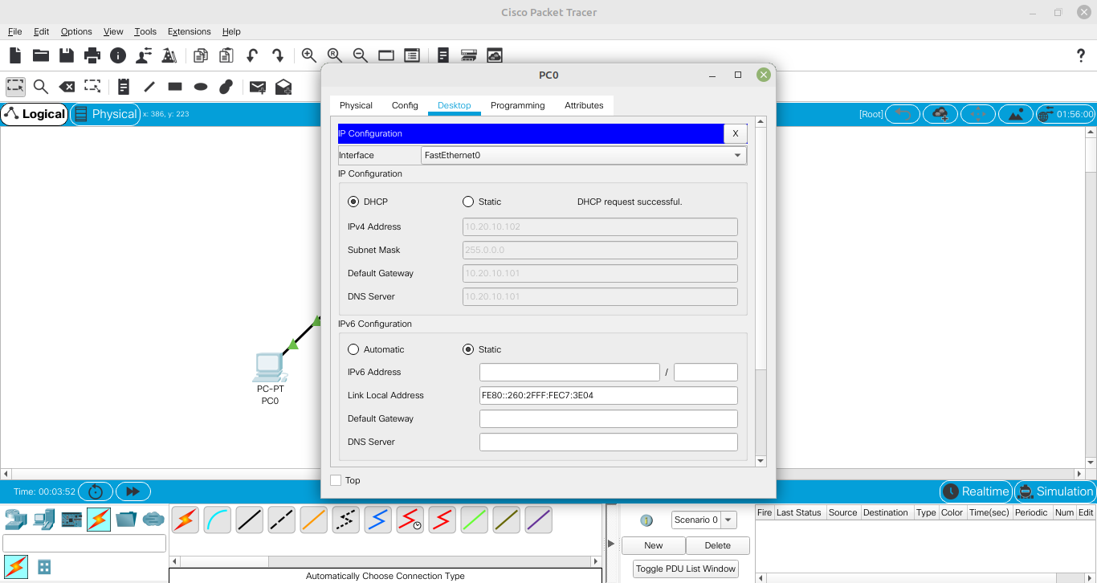

* 1. **Ring**

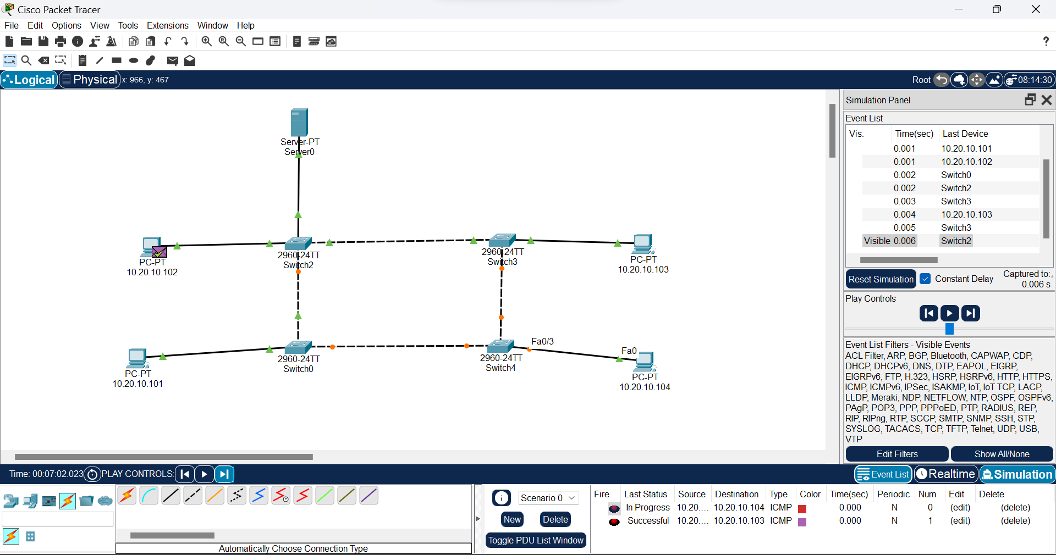

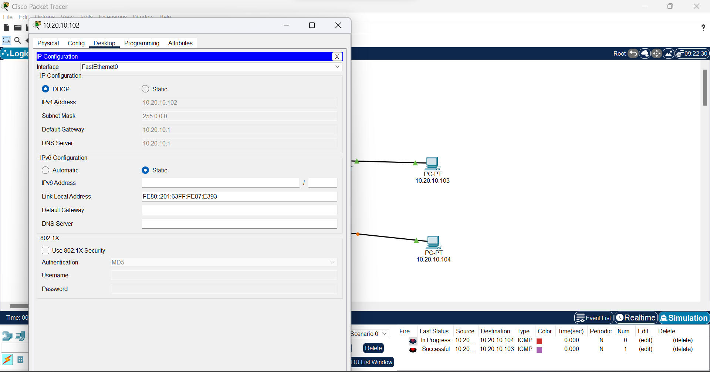

* 1. **Star**

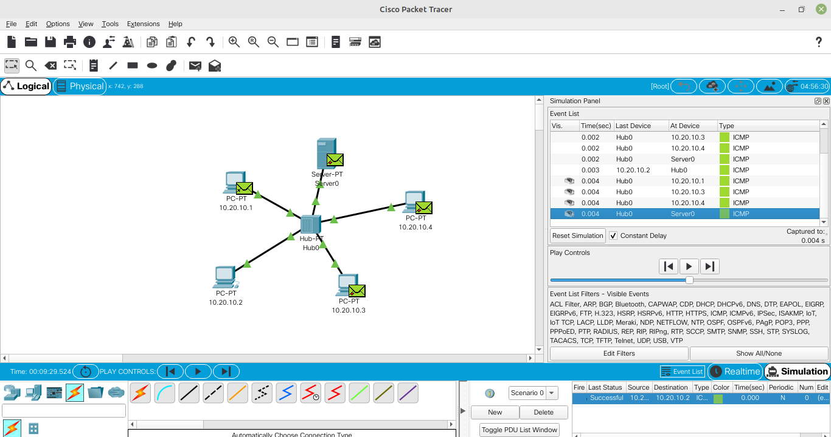

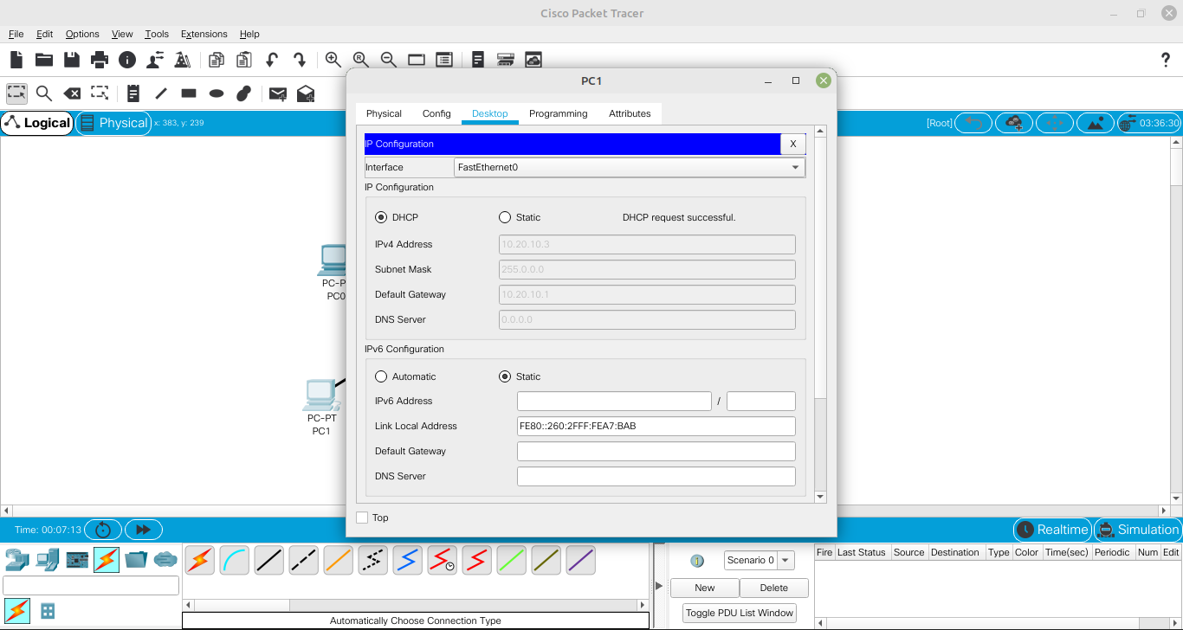

* 1. **Mesh**

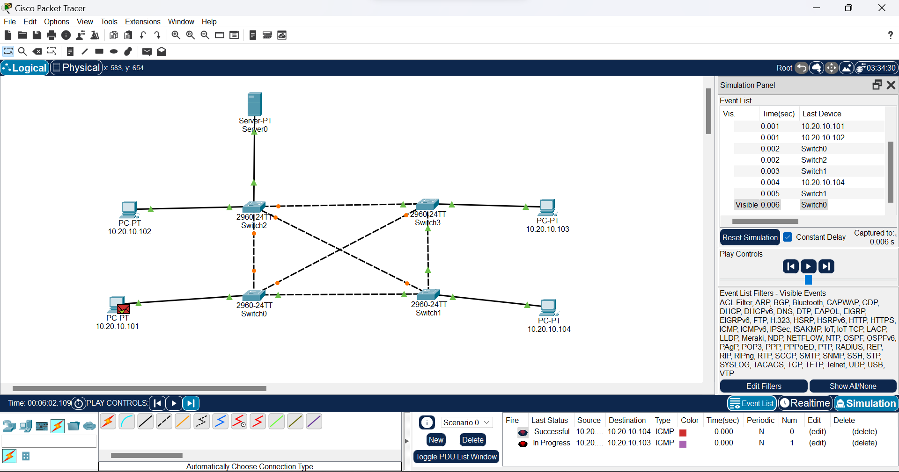

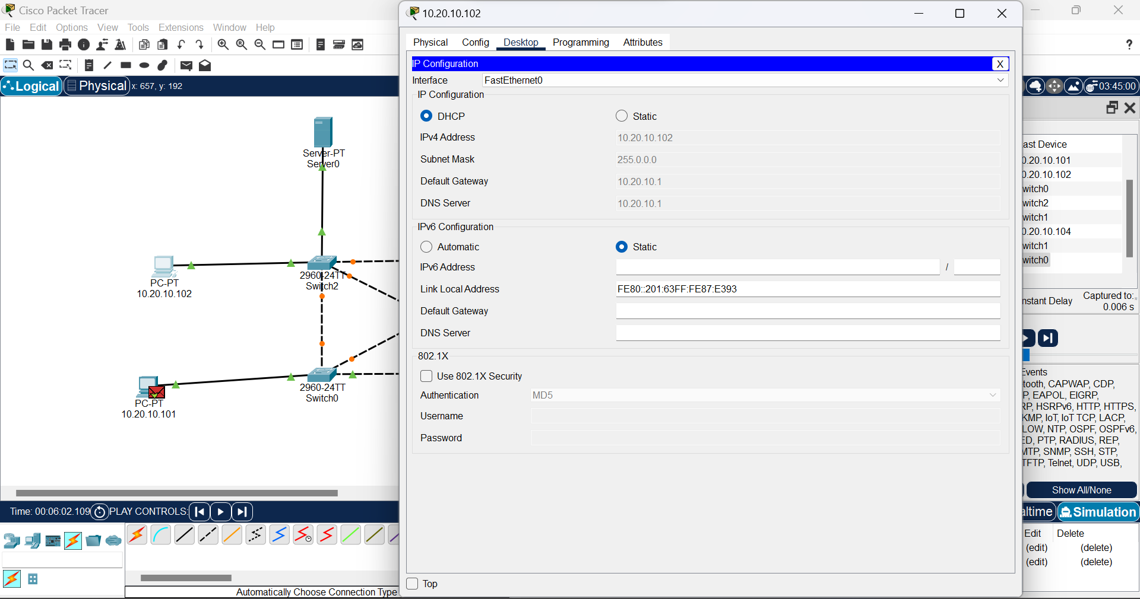

* 1. **Tree**

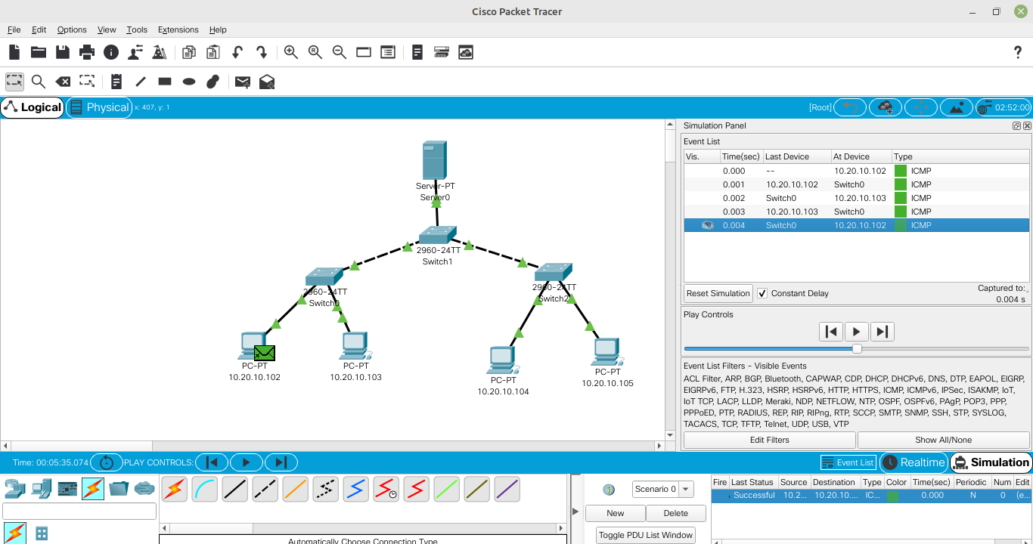



1. **FTP**

